**1. Refer the example code of single linked list.**

**a. Modify existing data structure to include below additional data members. Update all relevant existing functions to accommodate this member update and test.**

**{**

**char id[MAX_ID_LEN]; //let max id length be 5**

**int val;**

**}**

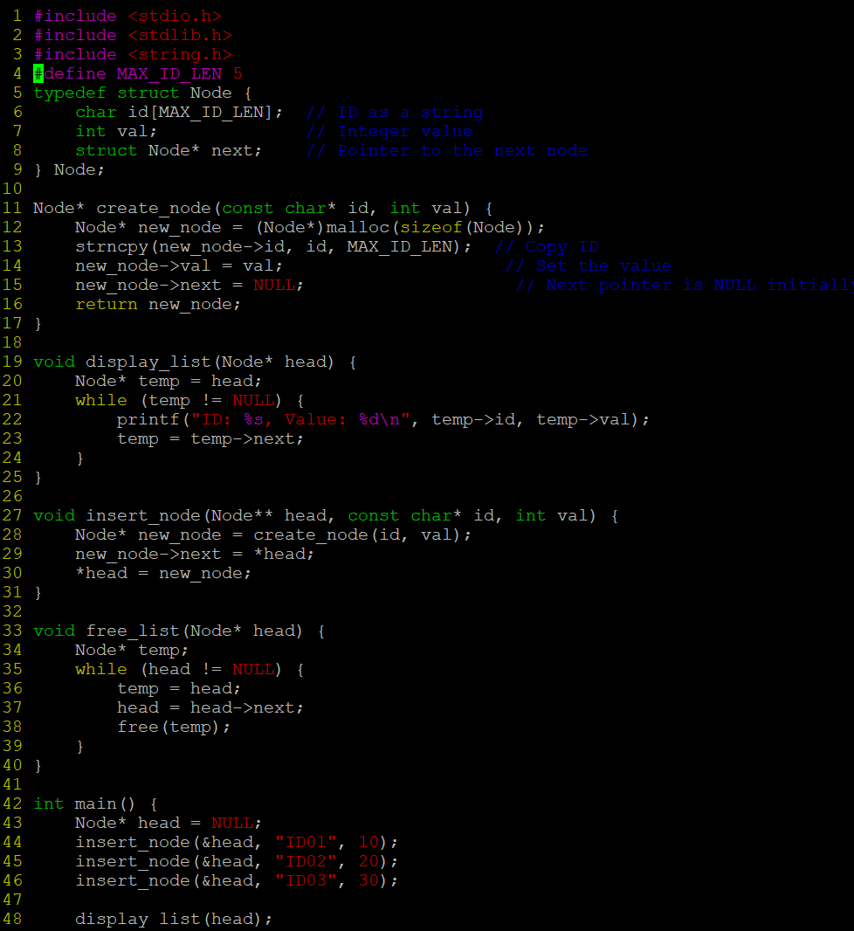

**OUTPUT:**

**b. Add a function below to perform search and update based on name (str) input.**

**extern int search_update_name(Node **, char *search, char *replace);**

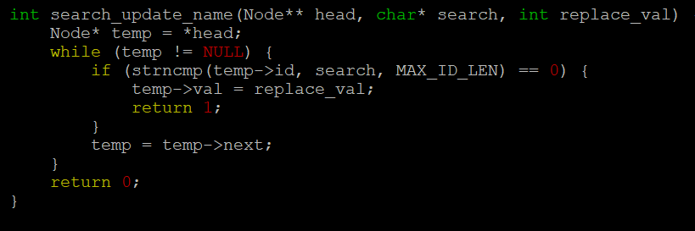

**OUTPUT:**

**c. Add functions below() to perform a sorted insert operation (ascending order) on the list based on name (str) and on val.**

**//insert based on name (str member) in increasing order**

**extern int sorted_insert_name(Node **, char *, int val);**

**//insert based on val in increasing order**

**extern int sorted_insert_val(Node **, char *, int val);**

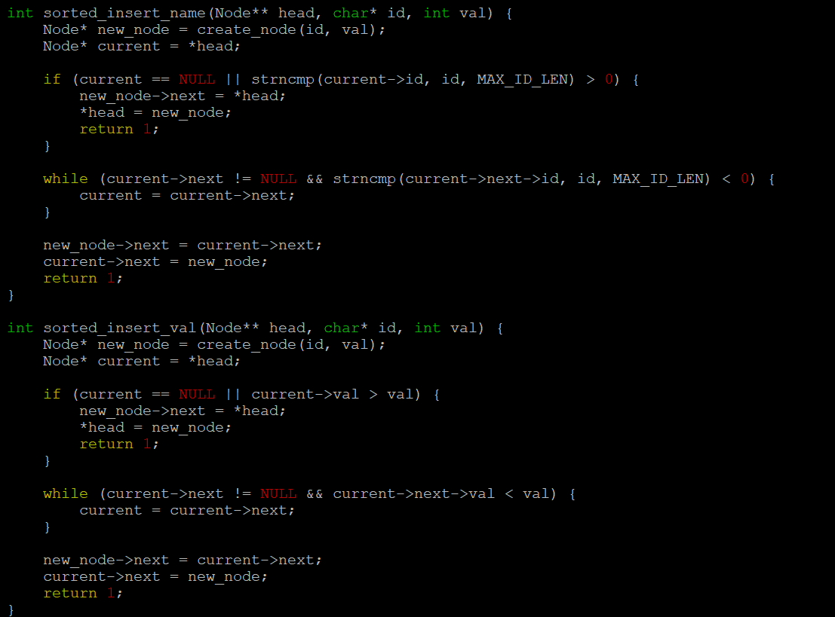

**OUTPUT:**

